**Experiment 6**

**Aim**: To create an activity diagram for the project Object Detection Solutions

**Theory:**

Activity diagram is basically a flowchart to represent the flow from one activity to another activity. The activity can be described as an operation of the system.

The control flow is drawn from one operation to another. This flow can be sequential, branched, or concurrent. Activity diagrams deal with all type of flow control by using different elements such as fork, join, etc.

An activity diagram is used to model the workflow depicting conditions, constraints, sequential and concurrent activities. On the other hand, the purpose of a Use Case is to just depict the functionality i.e. what the system does and not how it is done. So, in simple terms, an activity diagram shows ‘How’ while a Use case shows ‘What’ for a particular system.

Activity Diagram Notations:

**Initial State** – The starting state before an activity takes place is depicted using the initial state.

**Activity State** – An activity represents execution of an action on objects or by objects. We represent an activity using a rectangle with rounded corners.

**Action Flow or Control flows** – Action flows or Control flows are also referred to as paths and edges. They are used to show the transition from one activity state to another.

**Decision node and Branching** – When we need to make a decision before deciding the flow of control, we use the decision node.

**Guards** – A Guard refers to a statement written next to a decision node on an arrow sometimes within square brackets.

**Synchronization:** (Fork & Join)

**Fork** – Fork nodes are used to support concurrent activities.

**Join** – Join nodes are used to support concurrent activities converging into one. For join notations we have two or more incoming edges and one outgoing edge.

**Merge or Merge Eve**nt – Scenarios arise when activities which are not being executed concurrently have to be merged.

**Final State or End State** – The state which the system reaches when a particular process or activity ends is known as a Final State or End State. We use a filled circle within a circle notation to represent the final state in a state machine diagram

**Activity Diagram for the Project Object Detection Solution:**

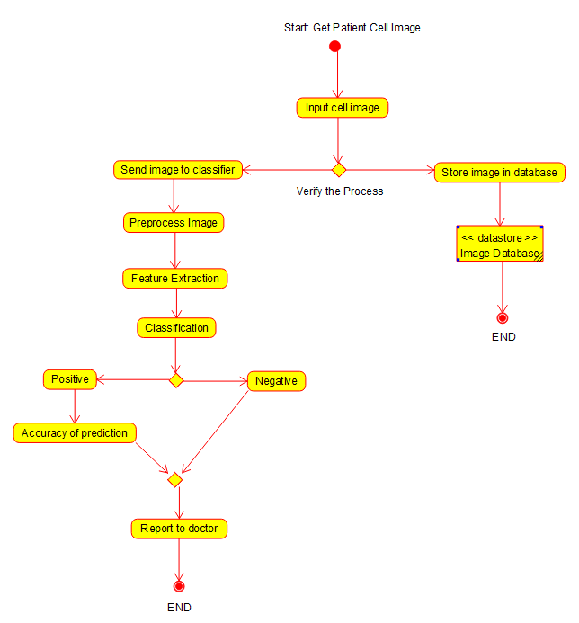

Cancer Detection in Cells

Activity Diagram for the Cancer Detection, use case of Object Detection Solution.It checks the process and then sends the image for Cancer detection and reports to doctor accordingly.

**Conclusion:**

The Activity Diagram for the project Object Detection Solution has been made.